Template Memo to Employees/Tenants

New State Law and Organics Collection Program

[The highlighted words indicate portions of the template that should be deleted or changed before distribution. Add specifics about recycling and/or composting programs at your building or business as applicable. With additional minor modifications, you may be able to use this to provide information to tenants upon move-in or move-out.]

Date: [insert date]

To: [Building Tenants / Employees]

From: [insert name or title, e.g., Property Manager or Business Manager]

Re: New State Law and Organics Collection Program

A new state law based on Senate Bill (SB) 1383 will go into effect on January 1, 2022, and it requires businesses and residents to separate organic materials, such as food scraps and plant trimmings, from the garbage. To comply with the new law, we are [starting a new / improving the] waste collection program at [building address / company name].

Studies consistently show that as much as 40% of what goes into the garbage is organic material that can be composted instead. When organic materials end up in the landfill, they decompose anaerobically (without oxygen) and produce methane, which is a major greenhouse gas. Separating organic materials and recyclables from the garbage helps conserve natural resources and slow climate change. Additionally, the organic materials can be transformed into compost for local farmers and gardeners to grow healthier crops. Free compost is available to residents. Please indicate interest in attending an event nearby at www.zerowastesonoma.gov/compost-for-the-climate.

HOW TO GET STARTED

A new green [container / cart / dumpster] for the collection of compostable organic materials will be located in the [kitchen area / dumpster enclosure / bathrooms] starting on [date]. The containers will be emptied [daily / weekly on ___]. Please see the next page for what can and cannot be composted.

COMPOST All food scraps and plant trimmings are accepted, including vegetable and fruit peelings, meat, bones, shells, dairy, twigs, leaves, flowers, coffee grounds, and tea bags.

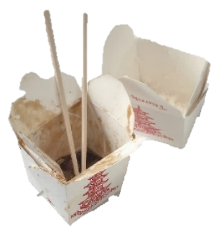
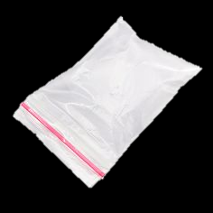
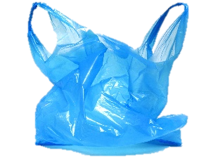
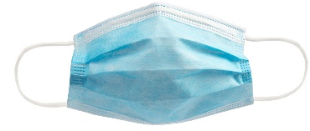
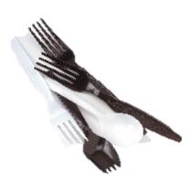
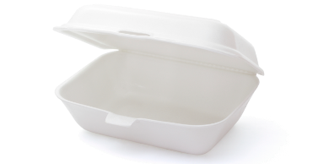
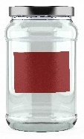
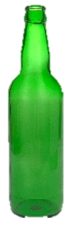
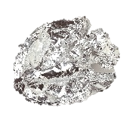
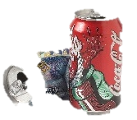
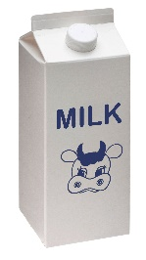
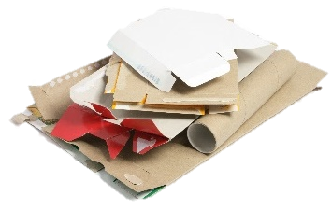
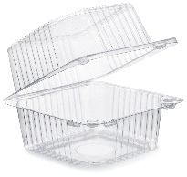
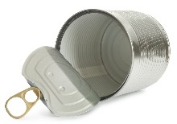
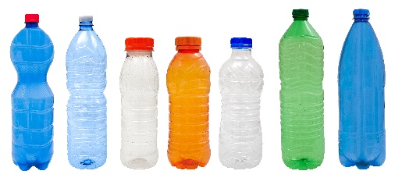
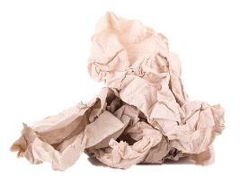
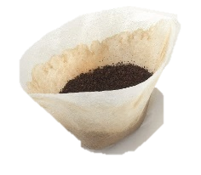
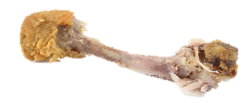
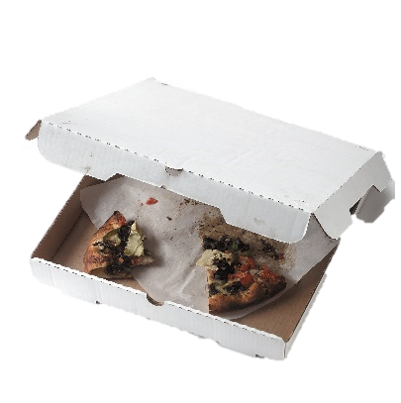
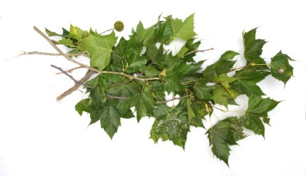
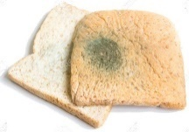
Questions? Visit www.zerowastesonoma.gov for more info or call (707) 565-3375.
LANDFILL Plastic bags or other soft plastic, polystyrene foam (Styrofoam), candy wrappers, chip bags, broken ceramic ware, disposable utensils/straws, paper with plastic coating (e.g., coffee cups, takeout containers, paper plates).
RECYCLE Clean and dry plastic bottles or containers (rigid only), metal or aluminum, cartons, glass jars or bottles, paper, and flattened cardboard.

